POSTMAN SETTINGS TO SEND REQUESTS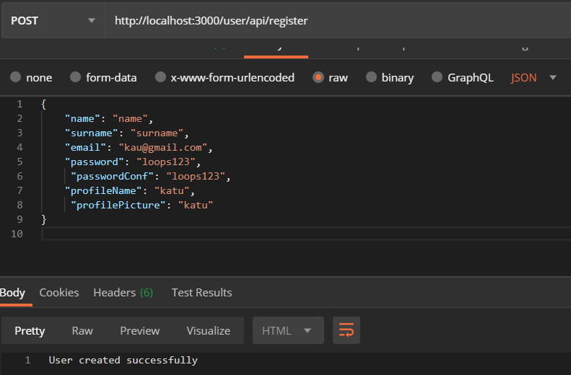

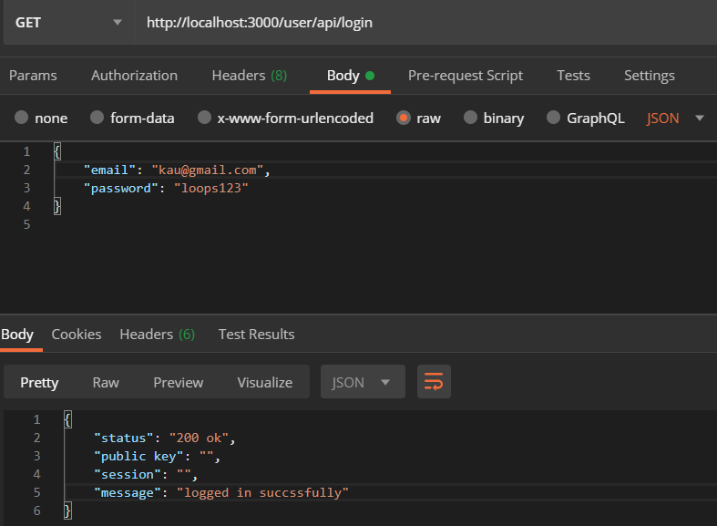

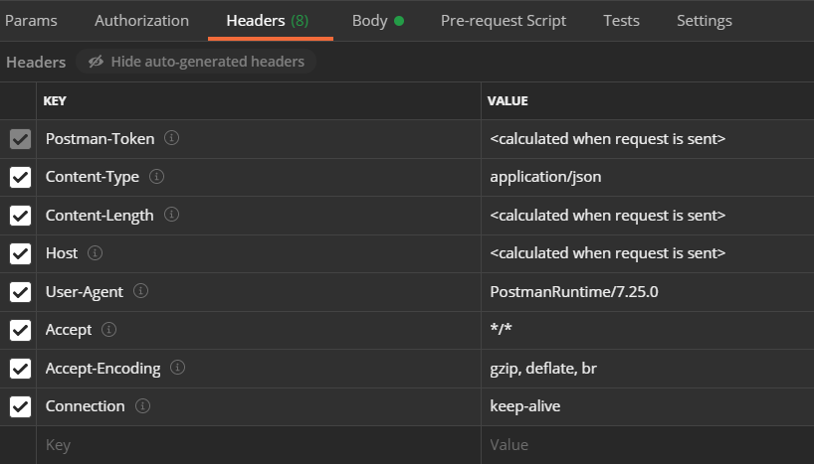

Pending

- User changing details -> what details can users change.

- All users should register through api/register with a default role. Admin can change these roles later. Should role changing functionality be done before Sunday.

- Forgot password.

- Can users have same usernames as long as emails are different?

- User ID is randomly generated.